Assignment 14
Sumedh Bagade
Deploy index.html to S3 static website hosting using jenkins pipeline
Steps:
1. Login to EC2 instance and configure jenkins.
2. Attach IAM role to EC2 instance for accessing S3 (full access permission)
3. On our github we have static-website repo containing index file. We need to clone this repo to our jenkins master.
4. Now go to jenkins dash and create a pipeline. Write a script, we need stages for complete process. First for cloning repo, second for creating s3 bucket, third for disablng public access block, fourth for creating bucket policy and last for deploying index.
5. After creating bucket in stage two we also need to enable static website hosting.
6. If we do not disable block public access we wont be able to access the website. We also need to create bucket policy. This will give public permission to read the object inside bucket allowing us to access webpage. Script for stage three and four is on next page
7. Run the pipeline and if build is successful try to access website. To access the static website we need URL. we can get this from S3 console. Select bucket > go to properties > scroll down to static website hosting > Copy URL from bucket website endpoint.
Result: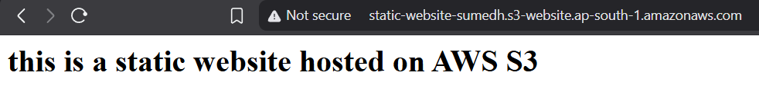

stage ("enable public access") {
steps {
sh '''
aws s3api put-public-access-block --bucket static-website-sumedh --public-access-block-configuration "BlockPublicAcls=false,IgnorePublicAcls=false,BlockPublicPolicy=false,RestrictPublicBuckets=false"
'''
}
}
stage ("create bucket policy") {
steps {
sh '''
aws s3api put-bucket-policy --bucket static-website-sumedh --policy '{
"Version":"2012-10-17",
"Statement":[{
"Sid":"PublicReadGetObject",
"Effect":"Allow",
"Principal":"*",
"Action":["s3:GetObject"],
"Resource":["arn:aws:s3:::static-website-sumedh/*"]
}]
}'
'''
} }

